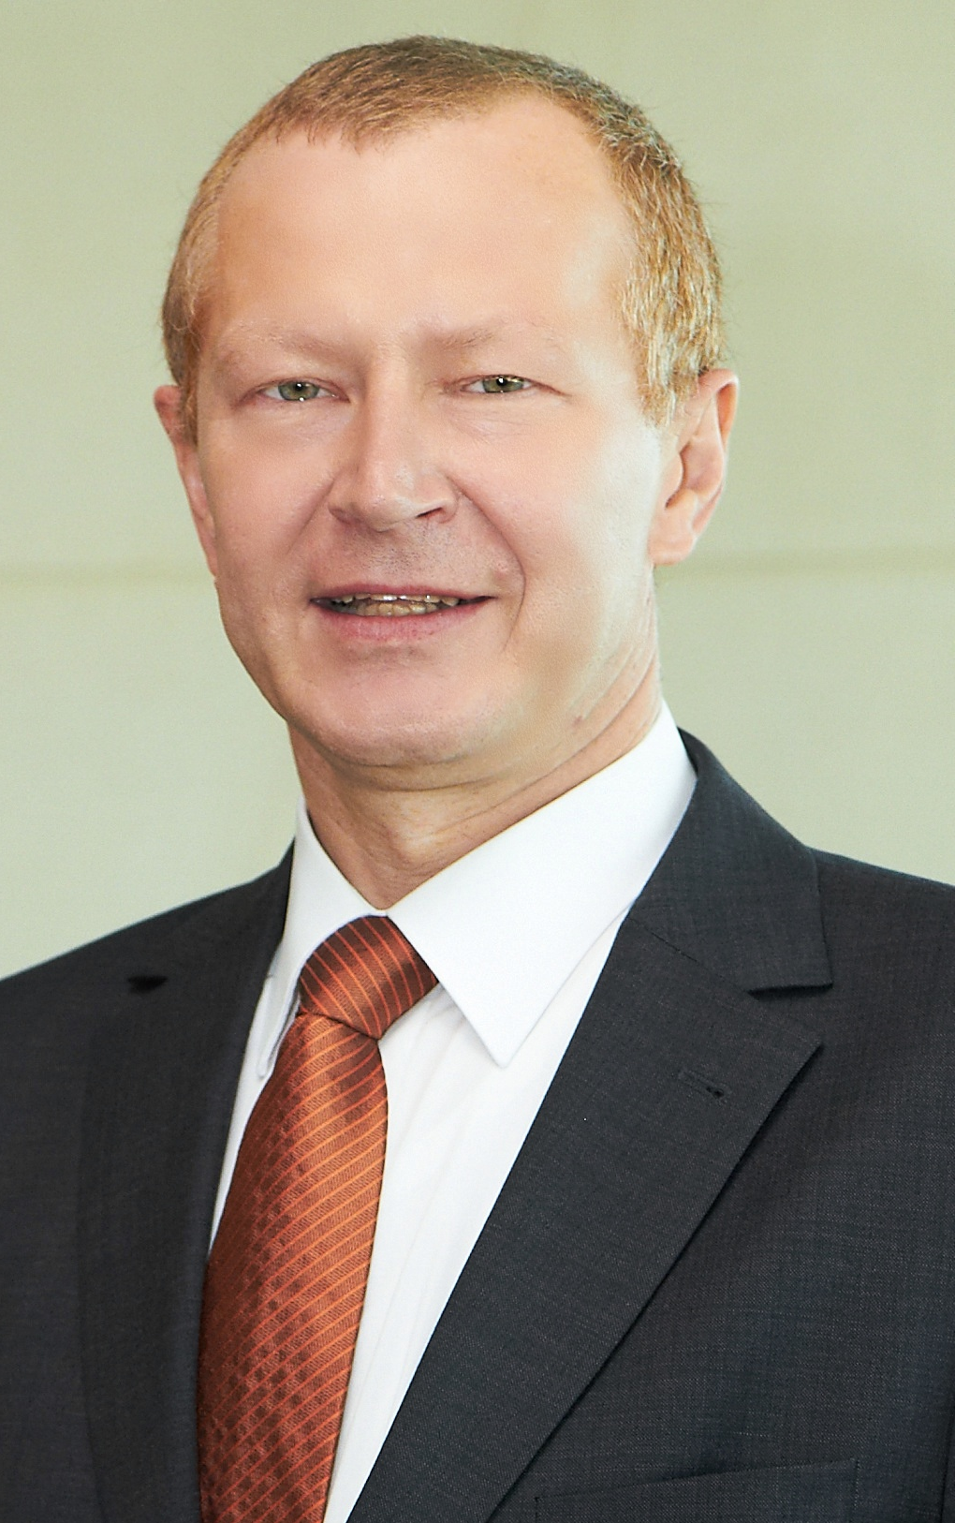
Curriculum Vitae

Johann KÖLTRINGER, Mag. Dipl.-Ing.

Austrian Dairy Association (VÖM)
Friedrich-Wilhelm-Raiffeisen-Platz 1
1020 Vienna

born December 31, 1962, Fridolfing

1974 – 1981 Humanistic Gymnasium, Salzburg

1982 – 1988 Studies Agricultural Science
Universität für Bodenkultur, Vienna

1984 – 1988 Studies Economics
Wirtschaftsuniversität Wien, Vienna

1988 – 1998 Austrian Farmers Association
Office Manager

1994 – 1998 Secretary within ÖVP-Parliamentary group,
Austrian Parliament

1999 – 2012 European Economic and Social Committee,
Member

2007 – 2012 Raiffeisen Klimaschutz-Initiative (RKI),
Director

since 2013 Raiffeisen Klimaschutz-Initiative (RKI),
Vice President

since 1998 Austrian Raiffeisen Association (ÖRV),
Division Economics, Agriculture and European Affairs

since 1999 Austrian Dairy Association (VÖM),
Director

Vienna, December 21, 2015

