Aurélie Trouvé
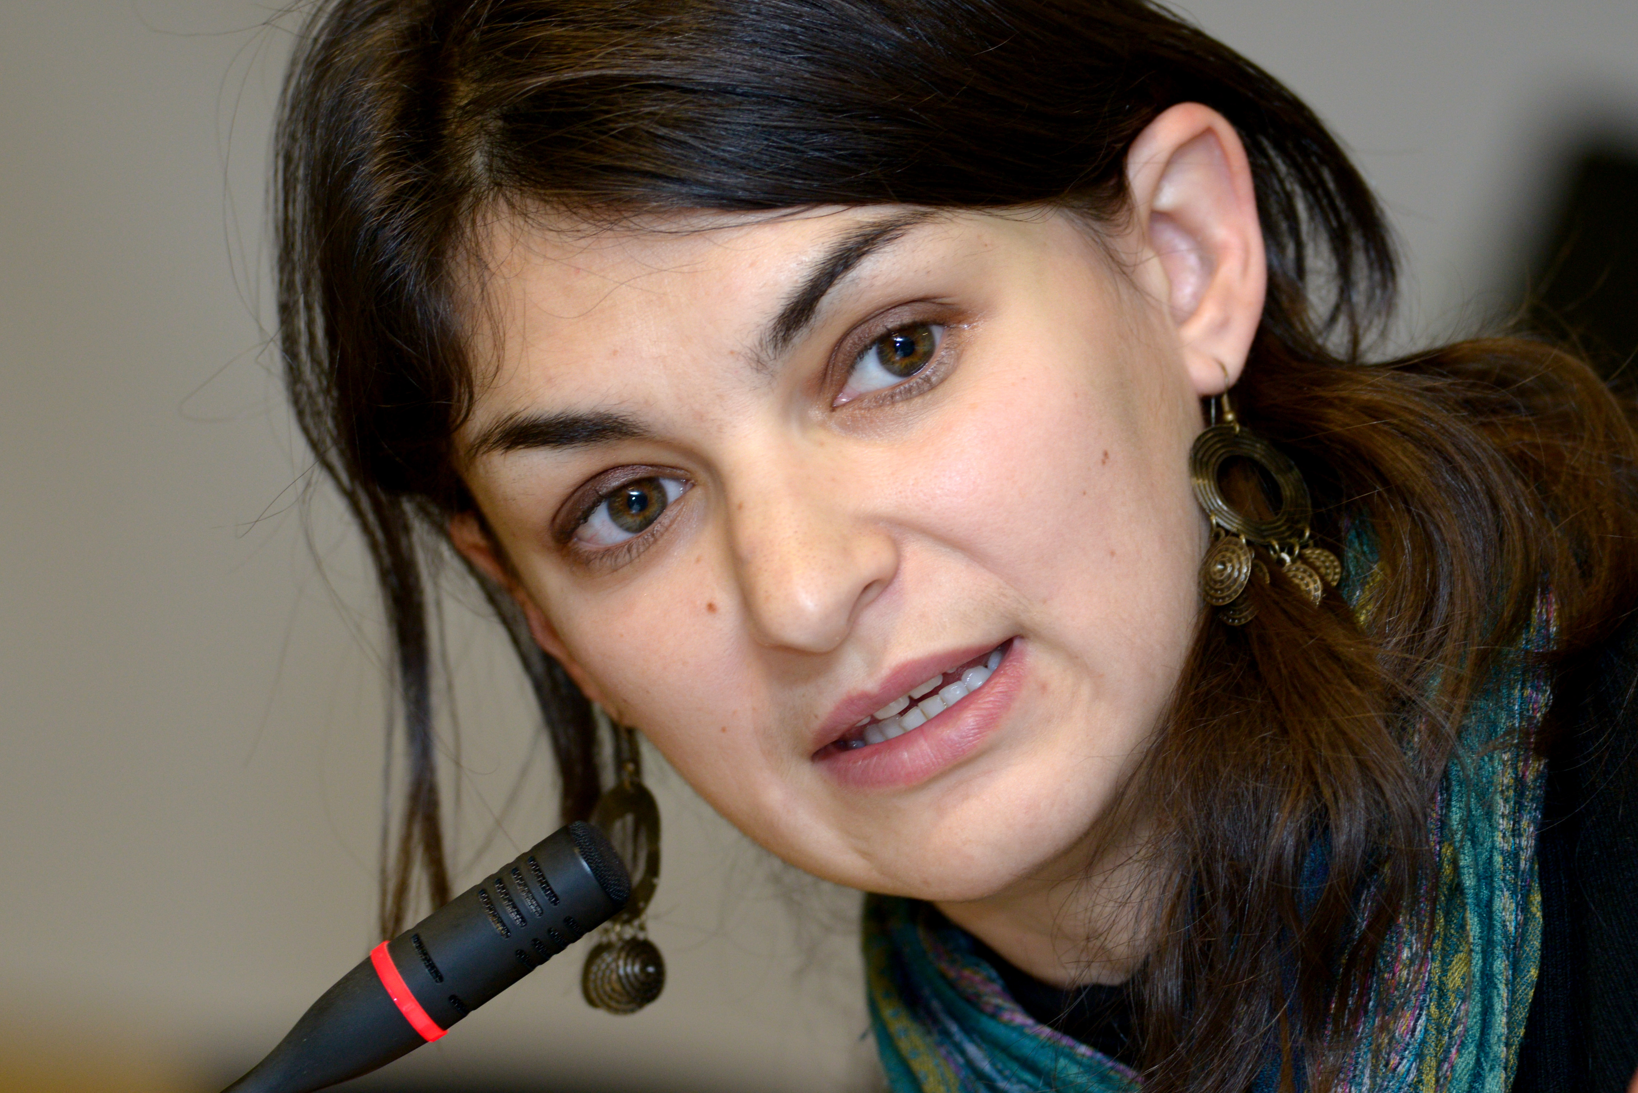

Aurélie Trouvé is reader in economics in AgroParisTech (Paris Institute of Technology for Life, Food and Environmental Sciences). She got a PhD in economics (2007), which dealt on agricultural policies of regional governments in European Union. She also has diplomas of Engineer of agronomy and Engineer of Water and Forests (since 2002).

Her work focuses on agricultural policies and rural development in the European Union. She is an expert for public and private actors (European Commission, Ministry of agriculture in France, agricultural and environmental organizations ...). She was appointed adviser to the Commissioner Dacian Ciolos and is currently leading a research project funded by the Ministry of Agriculture on market regulation prospects in the dairy sector. She participated in the coordination of several national research programs, including one on the integration of public goods in the Common Agricultural Policy (http://bip-pop.org/). She is co-responsible for agricultural policy seminars of the French Society of Rural Economy and member of the editorial board of the review “Economie rurale”.

